Polymer-Protein Hybrids that enhance the thermal activity of proteins
250820 group discussion M1 Shunya Sudo
Research Objectives
My research goal is to discover polymers that boost heat resistance without compromising activity for three enzymes: horseradish peroxidase, glucose oxidase, and lipase. I focus on three monomer types—zwitterionic, cationic, and hydrophobic—and apply Bayesian optimization to efficiently find the best composition ratios with minimal experiments. We start with MPC as the zwitterionic monomer, MTAC as the cationic monomer, and BMA as the hydrophobic monomer. Once we determine the optimal MPC/MTAC/BMA ratio, we will explore other hydrophobic units—EHMA, LMA, and MPTSSi—to identify the most effective hydrophobic component.

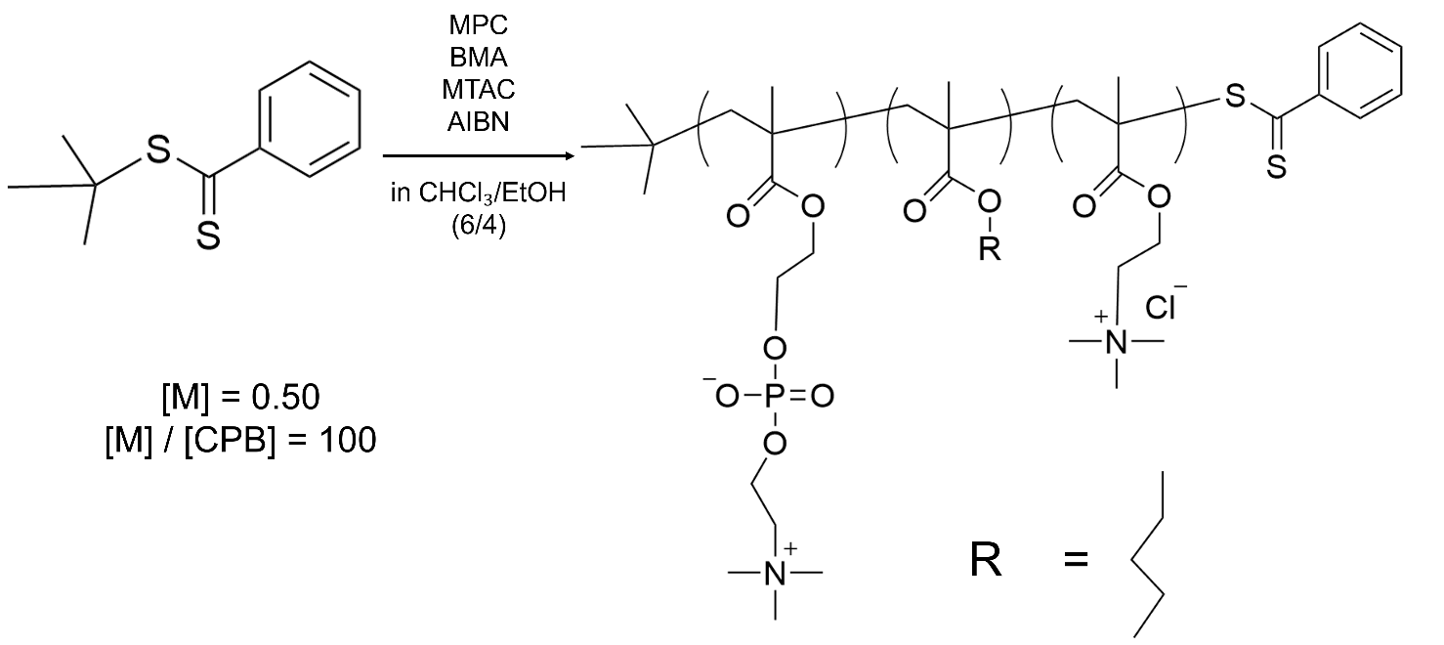

 | Feed Ratio (mol %) |  |  | Composition Ratio (mol %)
Polymer | MPC | BMA | MTAC | MPC | BMA | MTAC
PMBTA-1 | 80 | 4 | 16 | 84.4 | 2.5 | 13.1
PMBTA-2 | 80 | 16 | 4 | 78.6 | 15.9 | 5.5
PMBTA-3 | 30 | 14 | 56 | 30.4 | 14.2 | 55.4
PMBTA-4 | 30 | 56 | 14 | 32.7 | 33.2 | 34.1
PMBTA-5 | 55 | 22.5 | 22.5 | 50.3 | 22.4 | 22.4

Summary of this report
・The particle size distribution and zeta potential of the copolymers were obtained again.
・Reconsidering the research plan and rethinking material design

- Measurement of particle size distribution
The data obtained using water as the solvent was not clear, so the experiment was repeated.
The polymer was dissolved in an organic solvent, then dissolved and added to water.
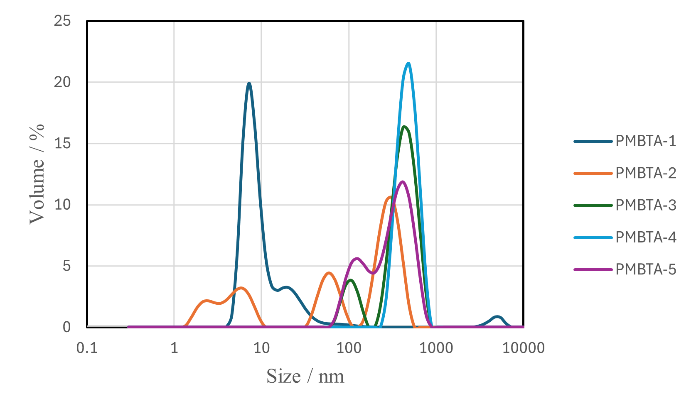
Figure 1. Particle size distribution of PMBTA (2025/7)
  - Experimental Methods
- The polymer was dissolved in DMSO (PMBTA-1, 2, 3) and EtOH (PMBTA-4, 5) to prepare a 50 mg/mL polymer stock solution.
- 10 μL of (1) was added to 990 μL of water.
- 780 μL of (2) was used for measurement.

1.2 Particle size distribution
Particle size distribution was measured for each of PMBTA-1-5.

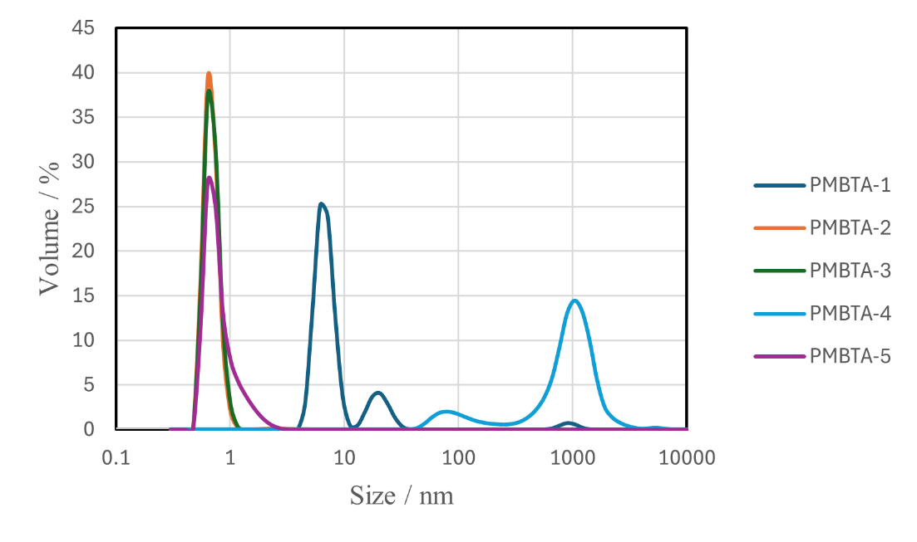
Figure 2. Particle size distribution of PMBTA (2025/8)
Copolymer | volume average diameter (Z-avg) (nm) | center diameter D50 (nm)
PMBTA-1 | 29.1 | 5.71
PMBTA-2 | 0.724 | 0.617
PMBTA-3 | 0.728 | 0.629
PMBTA-4 | 654 | 658
PMBTA-5 | 0.866 | 0.612
  - Except for PMBTA-4, the particles are distributed in small sizes.
- PMBTA-4 and 5 appear to be insoluble in solvents.
- The particle size became significantly smaller than when dissolved directly in water.
- It was found that dissolving the copolymer PMBTA in an organic solvent before measuring it with DLS was effective.

- Measurement of zeta potential
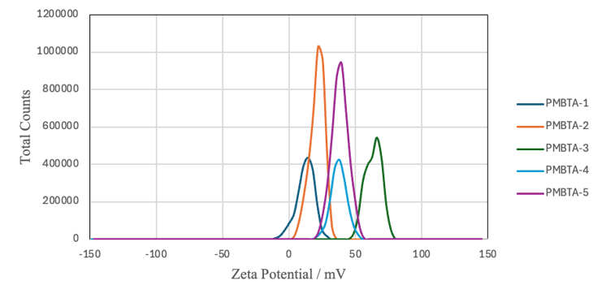
Figure 3. Zeta potential of PMBTA (2025/7)
2.1 Zeta potential
Measured simultaneously with the same solution as particle size distribution.
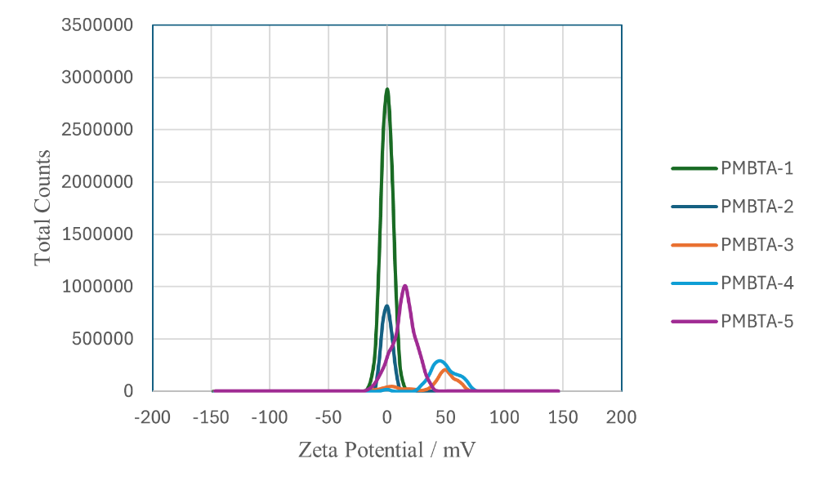
Figure 4. Zeta potential of PMBTA (2025/8)
- In July, the measurement was performed at 3 mg/mL, but this time, in order to accurately measure the particle size distribution, the concentration was 0.5 mg/mL, which may have been too low.
- This is considered reasonable because PMBTA-3 and 4 have high charges due to the high content of cationic monomer MTAC.
Copolymer | Average ζ (weighted mean) | D₅₀ (50 %)
PMBTA-1 | -0.161 | -2.57
PMBTA-2 | -0.144 | -2.77
PMBTA-3 | 40.9 | 46.1
PMBTA-4 | 48.1 | 45.8
PMBTA-5 | 14.2 | 12.4

- Research Plan (undecided)
- Considering the meaning of the three-element system.
- Focus on those that form complexes with polymers and proteins.
  - Determine whether a meeting was held at DLS.
  - Determine based on turbidity.
  - Investigate heat resistance within that area.
- The interaction with proteins when hydrophobicity is changed is measured using LogP as an indicator.
- Focus on proteins that aggregate at high temperatures.
  - This shows that adding the polymer we created prevents aggregation.
- Aim for a design that does not lose activity at high temperatures.
  - Are there any advantages to being able to react at high temperatures?
  - Plate reader not supported.
  - A general indicator of heat resistance is when it returns to room temperature.
- Matthew J. Tamasi, Advanced Materials, 2022, 34, 30 referencing the ratio of BMA and MTAC with good performance.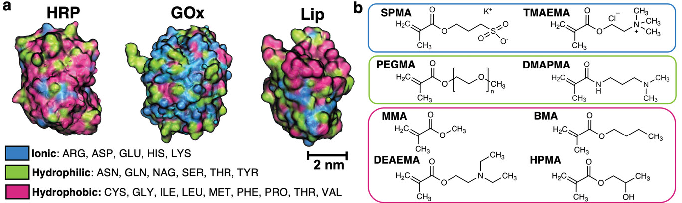
Figure 5. Target enzyme and monomer used (Matthew J. Tamasi, Advanced Materials, 2022, 34, 30)
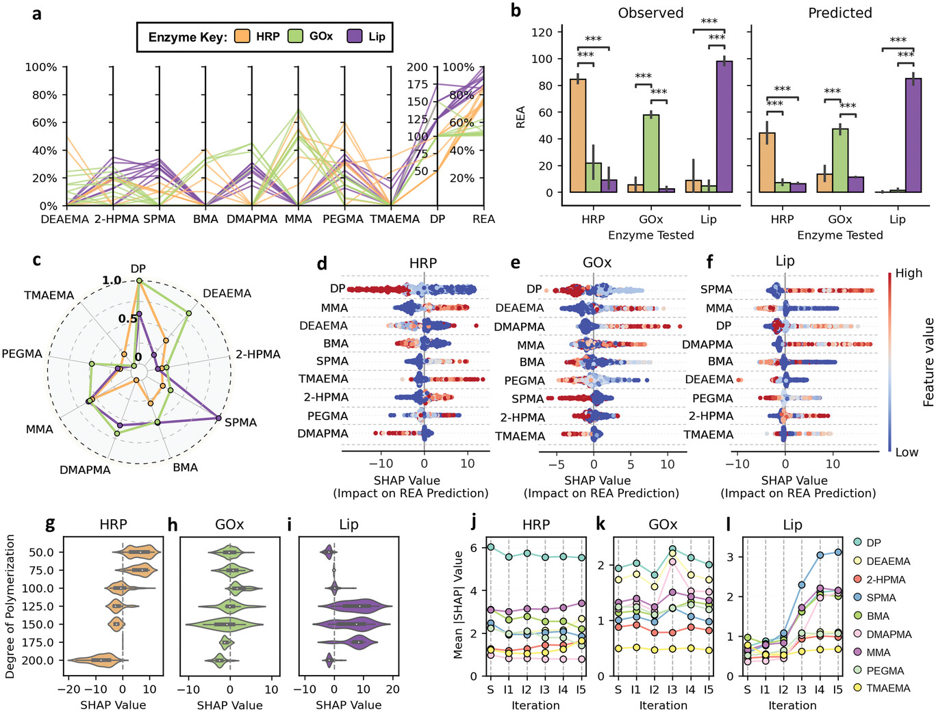
Figure 6. Analysis reveals distinct priorities in copolymer features for each protein.

Composition of the copolymer with the best performance

Enzyme | DP | SPMA | TMAEMA | PEGMA | DMAPMA | MMA | BMA | DEAEMA | HPMA | REA (%)
HRP | 75 | 0.17 | 0.24 | 0 | 0 | 0.55 | 0 | 0 | 0.04 | 81
GOx | 100 | 0.05 | 0 | 0.22 | 0.39 | 0 | 0.34 | 0 | 0 | 67.4
Lip | 125 | 0.32 | 0 | 0.25 | 0.31 | 0 | 0 | 0 | 0.12 | 108

- A combination of ionic, hydrophilic, and hydrophobic monomers achieves the highest REA for all enzymes.
  - Hetero (chemically diverse) is advantageous
  - The enzyme surface is scattered with chemical patches (hydrophobic/hydrophilic/charged) with diameters and intervals of approximately 1–2 nm, and amphiphilic random heteroadhesion that matches the statistical pattern is moderately strong and soft, maintaining functionality.
    - Loosely covering the enzyme with multiple points and weak interactions
  - MD simulations and experiments have shown that Random HeteroPolymer widely covers the HRP surface in organic solvents and forms loose complexes in water.
Brian Panganiban, Science, 2018, 359, 6381, 1239-1243
- However, the composition and DP differ depending on the enzyme.
  - Since polymers specific to each enzyme are optimal, it is better to focus on a single enzyme in our research.
  - It is not always necessary to have all of ionic, hydrophilic, and hydrophobic properties.
    - In the case of Lip, 2-HPMA 0.15, BMA 0.85, and no ionity recorded REA 64.7%.

- Future Plan (undecided)
・Consider research policies

